Educational Programming for Identified
Academically Talented Students Parent Information

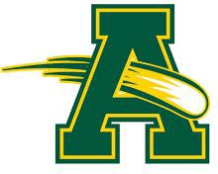

2022-2023
Amherst Exempted Village Schools 550 Milan Ave.
Amherst, OH 44001 www.amherstk12.org or
ESC of Lorain County
Programs and Services for Gifted Students: www.esclc.org

IDENTIFICATION
The identification process is in compliance with the Ohio Department of Education guidelines, and uses only nationally-normed tests on the state approved list. Subjective criteria are not used.

Referral: Students can be referred for assessment by parents, teachers, or students twice a year. Referral forms are available in the office of each school building or at www.esclc.org.

Screening: The NWEA Measures of Academic Progress (MAP)assessments are used starting in grade 2 through grade 8 for reading and math. Students are screened in grades 2 and 5 for cognition using the CogAT Test of Cognitive Abilities. Screening for Creative Thinking Ability also takes place in grades 2 and 5 using the Scales for Rating the Behavior Characteristics of Superior Students (SRBCSS).

Assessment: Following screening, small group and individual assessments are provided for potentially gifted students using the Naglieri Nonverbal Ability Test-3, Woodcock-Johnson IV, Stanford, and the WISC-V.

Gifted Identification Notice : The Amherst Exempted Village Schools gifted identification plan identifies students in the areas of superior cognitive ability, specific academic ability, and visual arts ability. The identification process consists of three phases: pre-assessment, assessment for screening, and assessment for identification. Parents are notified within 30 days of when the results are received from the testing company.

Assurances: The district meets the ODE requirements for evaluation of students who are culturally diverse, economically disadvantaged, students with physical and sensory disabilities and students who have limited English proficiency. The district identifies using only state-approved tests which are administered by trained personnel.

Written Education Plans: All students identified and served in a gifted program will have a Written Education Plan which is in compliance with the Ohio Operating Standards. Parents are provided with a copy of the plan in the fall of each school year. The goals stated on the plan are developed by the teacher or teachers responsible for providing service. Progress towards the goals is monitored through parent conferences and quarterly progress reports.

Written Acceleration Plans: All students who are subject or whole-grade accelerated will receive a Written Acceleration Plan.

Outside Testing: The district will accept outside testing for gifted students if the test is on the state-approved list, and was conducted in the previous twenty four months.

Transfer Students: The district will review testing from previous schools to determine whether students qualify for services in Amherst. Scores need to be from the previous twenty four months.

Acceleration: The district has a state approved plan in place. The specific referral, screening and

assessment process is detailed on the Amherst Exempted Village Schools or ESC websites.

Appeal: Amherst Exempted Village has an appeals process for decisions regarding screening and identification (Ohio Revised Code Section 3324.03). The initial step in the process is to submit a written statement to the building principal explaining your reason for the appeal of identification within 14 calendar days of receiving identification results.

Waiver: The district has a waiver of assignments procedure in place.

Withdrawal: Withdrawals require parent permission. The written withdrawal request may be submitted to the building principal or the gifted supervisor.

PROGRAM SERVICES

Grade K - 3 Clustered Classes: Students identified gifted in Superior Cognitive and/or Specific Academic Ability of 95% or above in the subject areas of Reading or Math are grouped together in selected classrooms. Services are provided by classroom teachers who have received professional development in gifted education which cover specific competencies for gifted education.

Grades 4/5 Language Arts: The curriculum is grade-enriched and content extends beyond the grade level standards. The content is enriched in breadth, depth and complexity.

Grades 4/5 Math: The curriculum is accelerated and the content goes beyond the grade level standards and differentiates the curriculum to meet the higher ability levels through enrichment and compacting.

Grade 6 Honors Language Arts: The curriculum is grade-enriched and content extends beyond the grade level standards. The content is enriched in breadth, depth and complexity. Must meet selection criteria based off of AJH advanced placement rubric.

Grades 6 Math 6+: The curriculum is grade-enriched and content extends beyond the grade level standards. The content is enriched in breadth, depth and complexity. Must meet selection criteria based off of AJH advanced placement rubric.

Grades 7-8 Language Arts (Honors and Advanced offered): The curriculum is accelerated and the content goes beyond the grade level standards and differentiates the curriculum to meet the higher ability levels through enrichment and compacting. Must meet selection criteria based off of AJH advanced placement rubric.

Grade 7-8 Math (Grade 7 Algebra 1, Grade 8 - Geometry): Must meet selection criteria based off of AJH advanced placement rubric. Math classes fulfill the requirements for high school credit and overall high school GPA.

High School Services: Services include Honors classes, AP, and College Credit Plus courses. Students with gifted identifications in specific content areas are provided with WEPs and service is reported to the state.

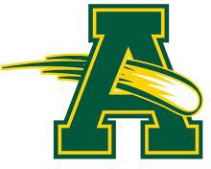

Mr. Steve Sayers, Superintendent

Mr. Mike Molnar, Assistant Superintendent

Powers Elementary School (440) 984-8670 Mr. Brian Teppner, Principal
Mrs. Mary Scott Williams, Assistant Principal

Nord Middle School (440) 984-4441 Mrs. Ashley Harigan, Principal

Amherst Junior High (440) 984-0324 Mr. Andrew Gibson, Principal
Mrs. Rhonda Neuhoff, Assistant Principal

Steele High School (440) 988-4433 Mr. Joe Tellier, Principal
Ms. Denise Abbott, Assistant Principal Mr. Nick Toney, Assistant Principal

Alice Ogonek, ESC Gifted Supervisor ogonek@esclc.org
440-324-5777 x1145

The ESC of Lorain County Gifted Consortium sponsors professional development for gifted educators as well as special events for gifted students that align specific curriculum to state standards.

Professional Development: Gifted educators’ workshops, Small group in-district sessions upon request, book studies
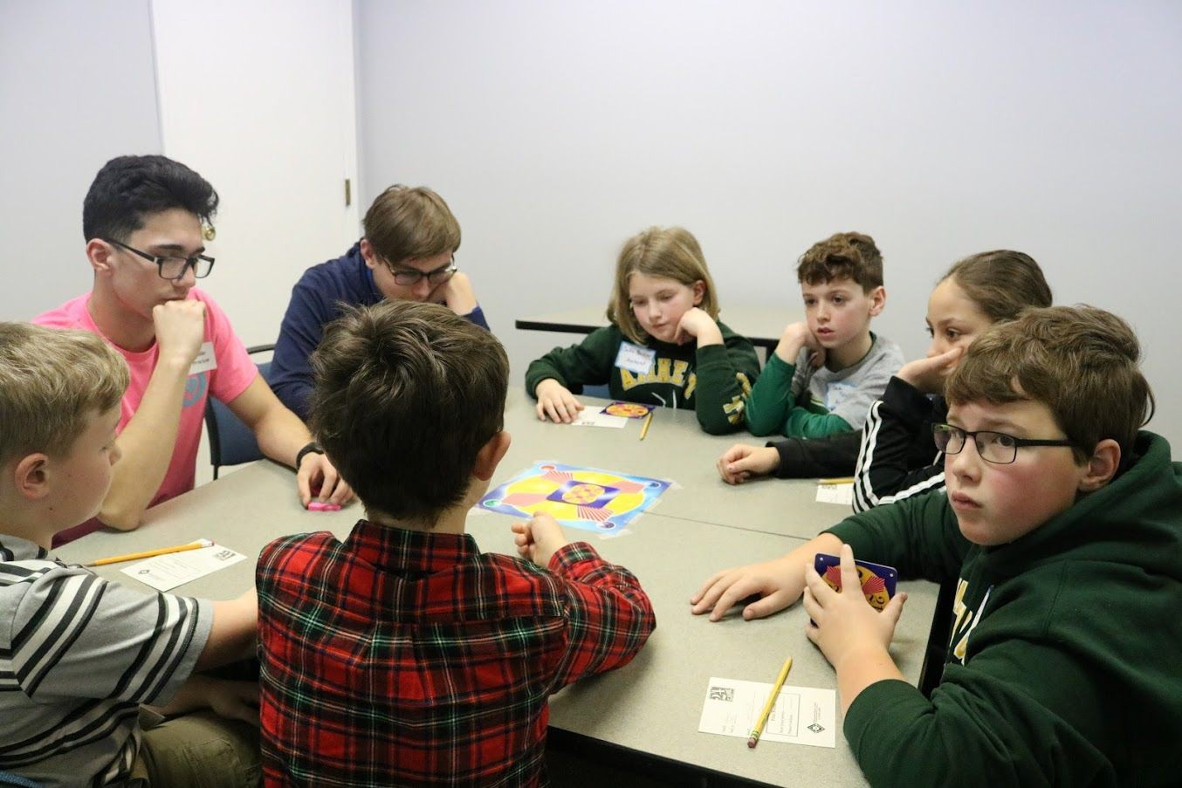

Countywide Gifted Programs/Services (services are limited in 2020-2021 due to COVID-19)
Classroom Attorney Workshops Mock Trial
Academic Challenge Visual Arts Identification
24 Game Semi-Finals/Finals
ACT Practice Testing Artist Workshops Young Authors

Educational Service Center of Lorain County 1885 Lake Avenue
Elyria, OH 44035
(440) 324-5777
www.esclc.org

Rev 06/2022

